Completed form to be forwarded to: Email: crossings@nrm.ca
Phone: 1-866-262-3654

This information is required before initiating a crossing agreement. Please ensure the form is completed accurately. Incomplete information will result in a delay in issuing the crossing agreement.

 |  | General Information
1. Requesting company or applicant:
Legal location/UTM:
Requesting company/applicant file number
(if applicable):
Requesting company/applicant drawing number
(if applicable):
2. Duration of use: |  | Temporary (less than a year):
 |  | Permanent (more than a year):
3. Work start date: |  | Work end date:

4. Complete the following tables for all the crossing vehicles.

Wheeled Vehicles
Vehicle Make and Model | Total Maximum Loaded Vehicle Weight (kg) | Maximum Loaded Weight per Axle Group (kg) | Drawing Showing Tire Configurations *
Front (steering):
Single (if necessary):
Tandem (2 axles):
Tridem (3 axles):
Other (specify):
Front (steering):
Single (if necessary):
Tandem (2 axles):
Tridem (3 axles):
Other (specify):
Front (steering):
Single (if necessary):
Tandem (2 axles):
Tridem (3 axles):
Other (specify):
* See an example for specifying wheeled vehicles in Figure 1.
Tracked Vehicles
Vehicle Make and Model | Total Vehicle Weight (kg) | Track Gauge or Track Separation (mm) | Track Contact Width (Shoe Size) (mm) | Track Length in Contact with the Ground (mm) | Ground Pressure (psi)
* See an example for specifying wheeled vehicles in Figure 2.

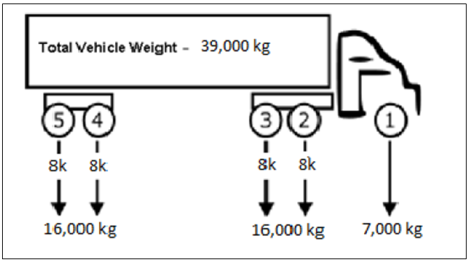
Figure 1: Wheeled Vehicle Specifications – Example

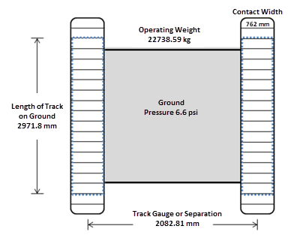
Figure 2: Tracked Vehicle Specifications – Example

