Crossings Procedures Manual

Vehicle Crossing Information Form

Completed form to be forwarded to: Email: [crossings@nrm.ca](mailto:crossings@nrm.ca)

Phone: 1-866-262-3654

This information is required before initiating a crossing agreement. Please ensure the form is completed accurately. Incomplete information will result in a delay in issuing the crossing agreement.

|  |  |  |  |  |
| --- | --- | --- | --- | --- |
|  | | **General Information** | | |
| 1. Requesting company or applicant: | |  | | |
| Legal location/UTM: | |  | | |
| Requesting company/applicant file # (if applicable): | |  | | |
| Requesting company/applicant drawing # (if applicable): | |  | | |
| 2. Duration of use: | | Temporary (less than a year): | |  |
| Permanent (more than a year): | |  |
| 3. Work start date: |  | Work end date: |  | |

4. Complete the following tables for **all** the crossing vehicles.

|  |  |  |  |
| --- | --- | --- | --- |
| **Wheeled Vehicles** | | | |
| **Vehicle Make and Model** | **Total Max Loaded Vehicle Weight (lbs)** | **Maximum Loaded Weight per Axle Group (lbs)** | **Axle Information** |
|  |  | Front (steering): Single (if necessary): Tandem (2 axles):  Tridem (3 axles): Other (specify): | Axle Separation (ft): Axle Width (ft):  Tire / Contact Width (in): Tire Pressure (psi): |
|  |  | Front (steering): Single (if necessary): Tandem (2 axles):  Tridem (3 axles): Other (specify): | Axle Separation (ft): Axle Width (ft):  Tire / Contact Width (in): Tire Pressure (psi): |
|  |  | Front (steering): Single (if necessary): Tandem (2 axles):  Tridem (3 axles): Other (specify): | Axle Separation (ft): Axle Width (ft):  Tire / Contact Width (in): Tire Pressure (psi): |

Crossings Procedures Manual

Vehicle Crossing Information Form

|  |  |  |  |  |  |
| --- | --- | --- | --- | --- | --- |
| **Tracked Vehicles** | | | | | |
| **Vehicle Make and Model** | **Total Vehicle Weight (lbs)** | **Track Gauge or Track Separation (ft)** | **Track Contact Width (Shoe Size) (Inches)** | **Track Length in Contact with the Ground (in)** | **Ground Pressure (psi)** |
|  |  |  |  |  |  |
|  |  |  |  |  |  |
|  |  |  |  |  |  |
|  |  |  |  |  |  |
|  |  |  |  |  |  |
|  |  |  |  |  |  |

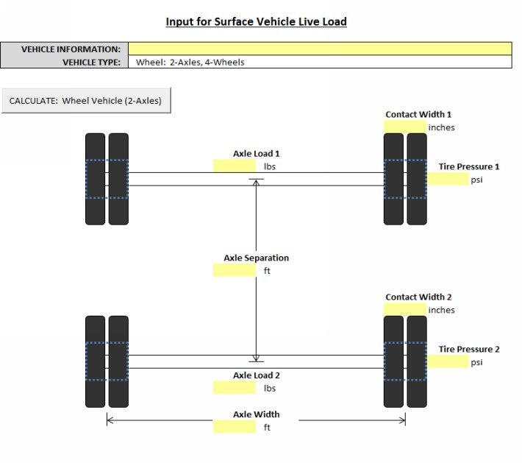

|  |  |
| --- | --- |
| **VEHICLE INFORMATION:**  **VEHICLE TYPE:** |  |
| Wheel: 2-Axles, 4-Wheels |



|  |  |
| --- | --- |
| **VEHICLE INFORMATION:**  **VEHICLE TYPE:** |  |
| Wheel: 2-Axles, 4-Wheels |



|  |  |
| --- | --- |
| **VEHICLE INFORMATION:**  **VEHICLE TYPE:** |  |
| Wheel: 2-Axles, 4-Wheels |



|  |  |
| --- | --- |
| **VEHICLE INFORMATION:**  **VEHICLE TYPE:** |  |
| Wheel: 2-Axles, 4-Wheels |



|  |  |
| --- | --- |
| **VEHICLE INFORMATION:**  **VEHICLE TYPE:** |  |
| Wheel: 2-Axles, 4-Wheels |

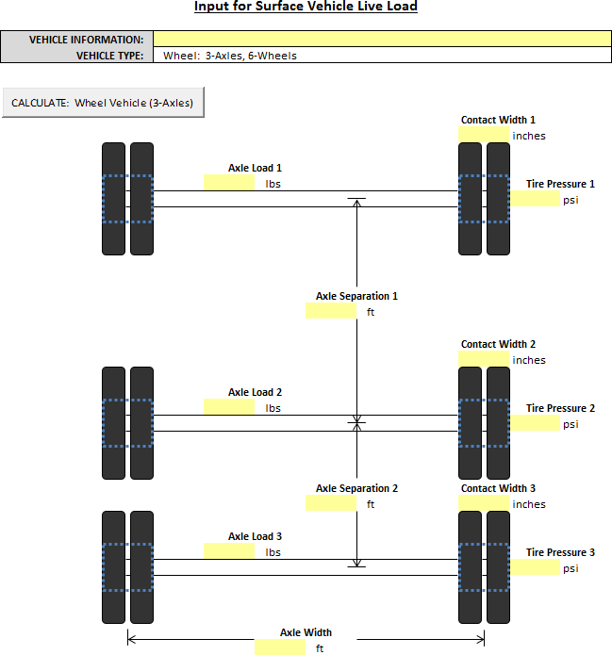

**VEHICLE INFORMATION:**

**VEHICLE TYPE:**



**VEHICLE INFORMATION:**

**VEHICLE TYPE:**



**VEHICLE INFORMATION:**

**VEHICLE TYPE:**



**VEHICLE INFORMATION:**

**VEHICLE TYPE:**



**VEHICLE INFORMATION:**

**VEHICLE TYPE:**

**VEHICLE INFORMATION:**

**VEHICLE TYPE:**

**lbs**

**psi**

**lbs**

**psi**

**lbs**

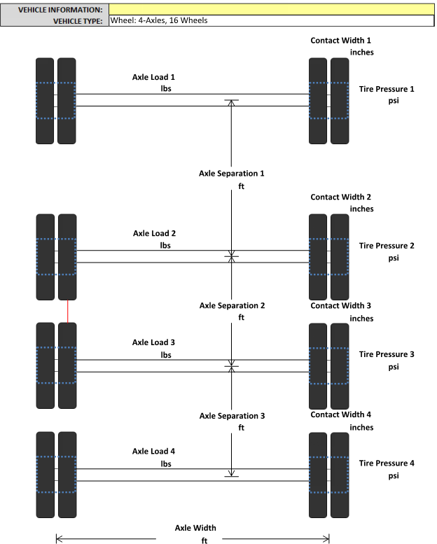

**lbs**

**psi**

**psi**

**VEHICLE INFORMATION:**

**VEHICLE TYPE:**

**lbs**

**psi**

**lbs**

**psi**

**lbs**



**lbs**

**psi**

**psi**

**VEHICLE INFORMATION:**

**VEHICLE TYPE:**

**lbs**

**psi**

**lbs**

**psi**

**lbs**



**lbs**

**psi**

**psi**

**VEHICLE INFORMATION:**

**VEHICLE TYPE:**

**lbs**

**psi**

**lbs**

**psi**

**lbs**



**lbs**

**psi**

**psi**

**VEHICLE INFORMATION:**

**VEHICLE TYPE:**

**lbs**

**psi**

**lbs**

**psi**

**lbs**



**lbs**

**psi**

**psi**

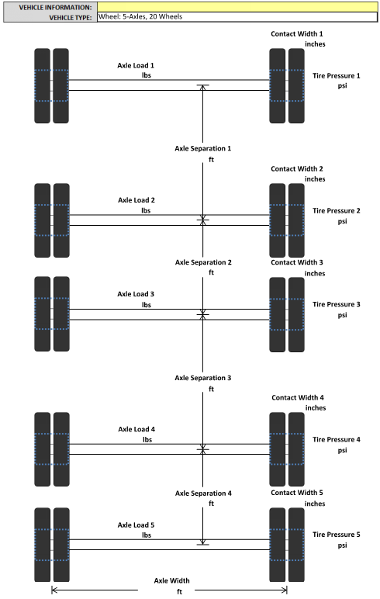

|  |  |
| --- | --- |
| **VEHICLE INFORMATION:**  **VEHICLE TYPE:** |  |
| Wheel: 5-Axles, 20 Wheels |



|  |  |
| --- | --- |
| **VEHICLE INFORMATION:**  **VEHICLE TYPE:** |  |
| Wheel: 5-Axles, 20 Wheels |



|  |  |
| --- | --- |
| **VEHICLE INFORMATION:**  **VEHICLE TYPE:** |  |
| Wheel: 5-Axles, 20 Wheels |



|  |  |
| --- | --- |
| **VEHICLE INFORMATION:**  **VEHICLE TYPE:** |  |
| Wheel: 5-Axles, 20 Wheels |



|  |  |
| --- | --- |
| **VEHICLE INFORMATION:**  **VEHICLE TYPE:** |  |
| Wheel: 5-Axles, 20 Wheels |

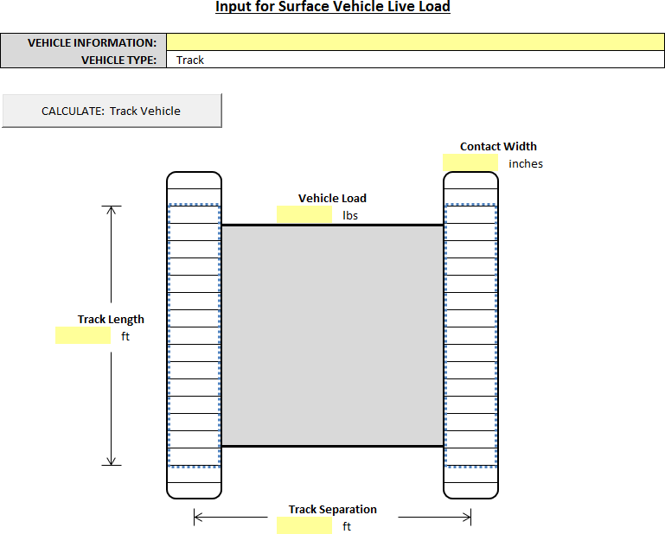

|  |  |
| --- | --- |
| **VEHICLE INFORMATION:**  **VEHICLE TYPE:** |  |
|  |



|  |  |
| --- | --- |
| **VEHICLE INFORMATION:**  **VEHICLE TYPE:** |  |
|  |



|  |  |
| --- | --- |
| **VEHICLE INFORMATION:**  **VEHICLE TYPE:** |  |
|  |



|  |  |
| --- | --- |
| **VEHICLE INFORMATION:**  **VEHICLE TYPE:** |  |
|  |



|  |  |
| --- | --- |
| **VEHICLE INFORMATION:**  **VEHICLE TYPE:** |  |
|  |